**Ex2 – Part 2 – Report**

**Model’s config:**

* Criterion: NLL-Loss
* Epochs: 10
* Learning Rate: 0.0003
* Batch Size: 1
* Dropout Rate: 0.3
* Number of LSTM layers: 1
* Embedding Size: 300
* Hidden Size: 512
* Optimizer: Adam
* RNN type: LSTM

**Max sentence length:** 15 words

**Best Train Loss:** 0.0526

**Best Dev Loss:** 0.0518

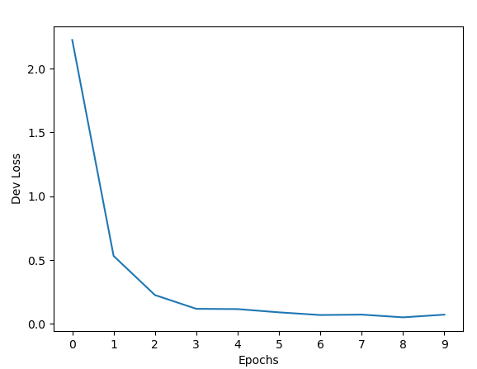

**Best BLEU score:** 96.7

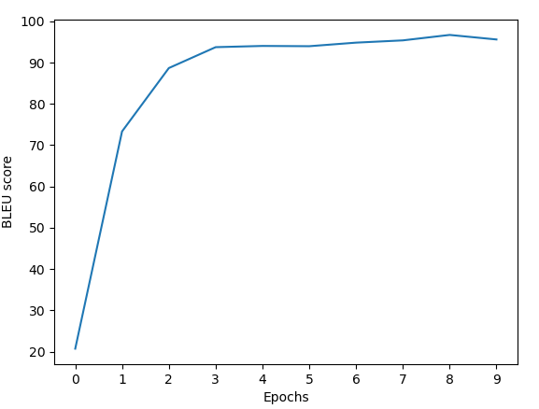

**Total runtime (on GPU):** 162 seconds (~ 2.7 minutes)

**Test BLEU score:** 98.718

**Test Best Loss:** 0.0265

Overall, we can tell that the attention-based model performs a lot better than the Vanilla RNN-based Encoder-Decoder with an improvement of ~14 BLEU scores on the Dev set and ~14 BLEU scores on the Test set.

In manor of run time, the attention-based model took ~10 seconds longer than the RNN-based for the training and ~0.2 seconds longer for the evaluation.